Q1. (2013)10 pts)
How many nodes does the binomial heap BH={ B₂ B₄ B₇ B₁₀ B₁₃ B₁₇ } have?
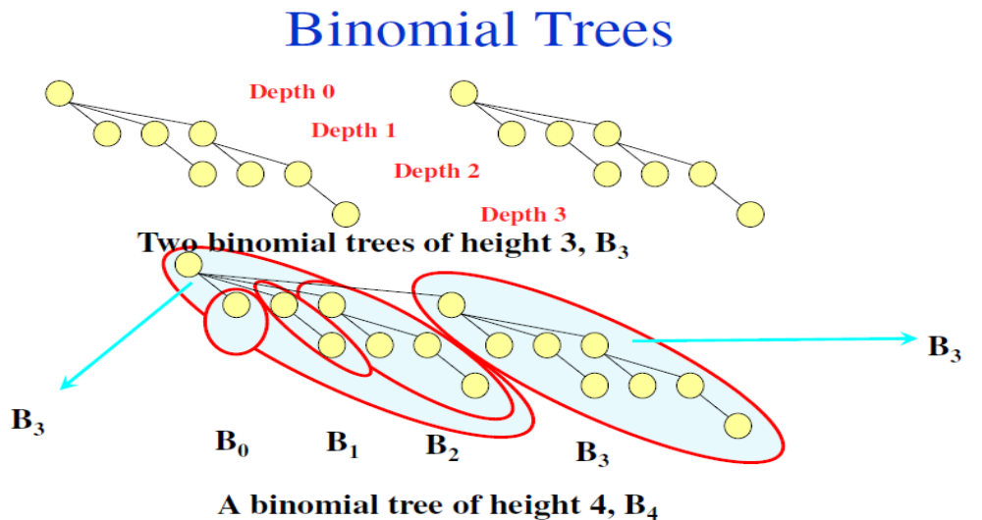
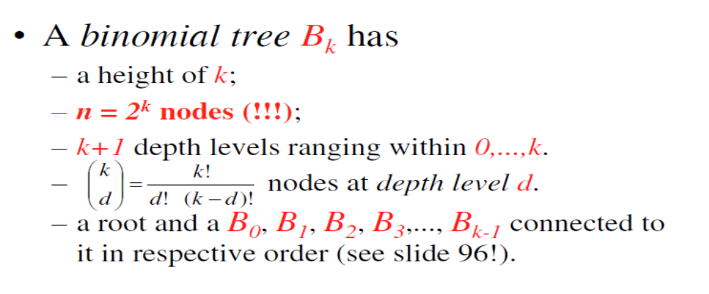

Q2. (2011) (10+10+10=30pts)

The two largest binomial trees in an n-node binomial heap BH is B₁₂ and B₈.
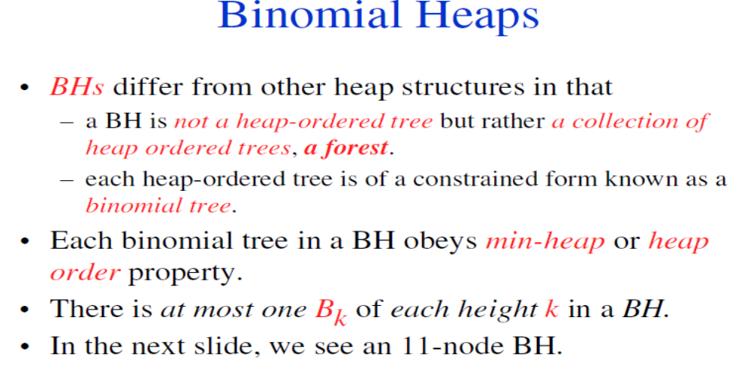

- (10pts)
Give a range for n such that its lower and upper limits specify the least and most crowded binomial heaps, respectively. In other words, how many nodes, at least and at most, may such a BH composed of?

- (10pts)
How many nodes are there at the most crowded depth level of the most crowded binomial tree in the above BH?

- (10pts)
Suppose the most crowded BH in (a) and that the node with the minimum key is at the root of B₈. Exactly, how many comparisons does it take to find the minimum key?

Q3. (2005) Consider a binomial queue with 9874 nodes.
    - (5pts) Which binomial trees is it composed of?
    - (5pts) How many nodes does the largest tree have in its most crowded depth level(s)? Which level(s) are they?

Q4. (2013) (5+10+10+15=40pts)
Suppose a binomial heap BH is devised by merging two binomial heaps each with n=2^{k}-1 keys.

- How many nodes, in terms of n, does BH contain?

- What binomial trees is BH composed of?

- In terms of n, how many binomial trees is BH exactly composed of?

- How many keys are there, in terms of n, in the most crowded depth level of the largest
binomial tree?

Q5. (2014) (5 + 10 pts)
How many comparisons, in terms of n, does it take to find the node with the minimum key in a binomial heap with n=2^{k} -3 elements
- in the worst case, and
- in the average case

Q6. 2013-Quiz

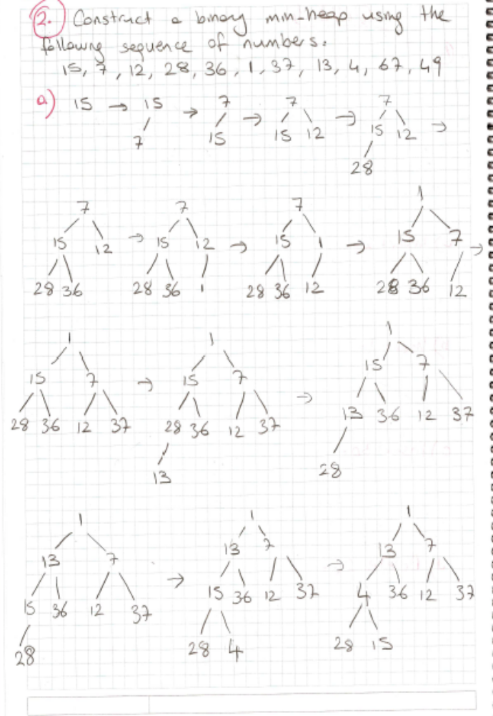
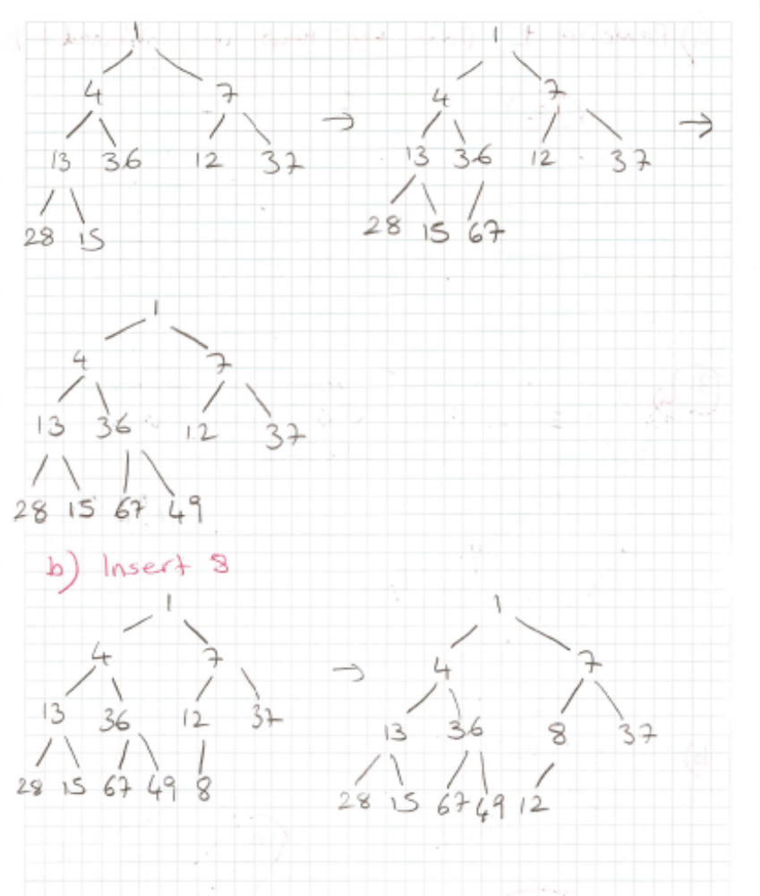
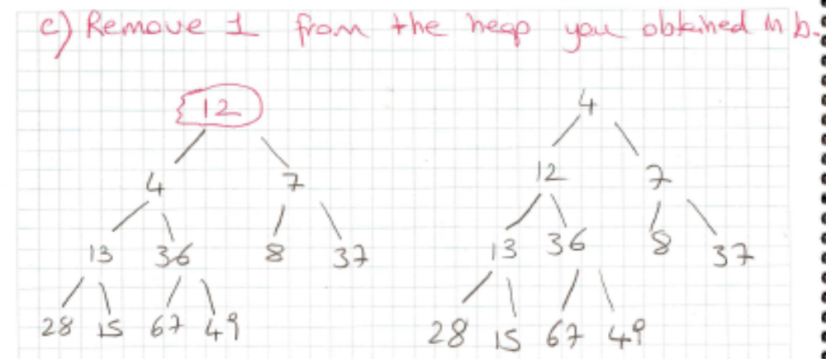

Q7. (2015)(10 pts)
Suppose you have two leftist heaps L₁ and L₂ with n elements in total. How many comparisons does it take exactly to merge L₁ and L₂ in terms of n?
- at most (worst case), and
- at least (best case)

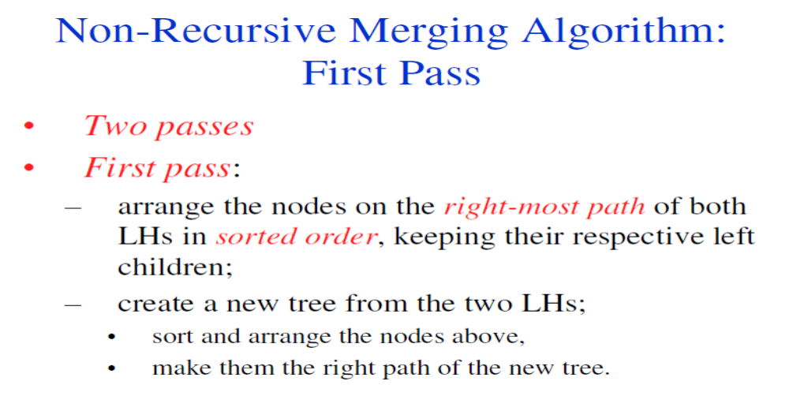
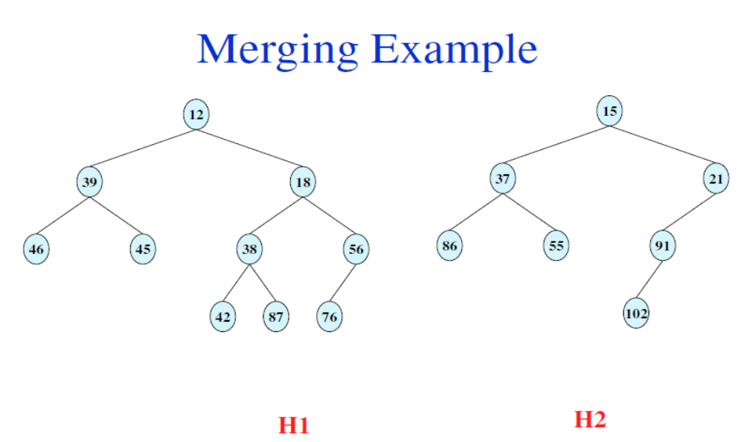
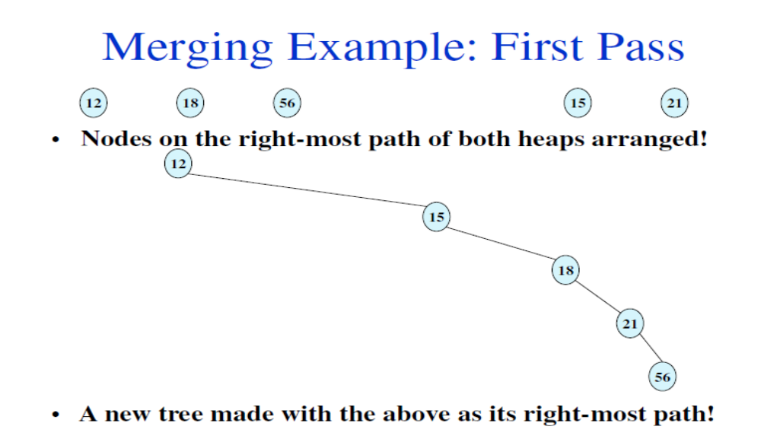

Q8. (2013) (8+8=16 pts) (HOMEWORK)
Consider two binomial queues BQ₁ and BQ₂ with n=2^{k} and m=2^{l} elements, respectively, where
k<l.

- One DeleteMin is performed at each binomial queue and then they are merged to BQ_{M}. How long does it take, in average, to find the minimum key in BQ_{M}?

- Suppose that BQ₁ and BQ₂ are first merged, and then two DeleteMins are performed. Suppose further that both minimum keys are at B_{k}. The second minimum key, located among the children of the root, is at the root of the most crowded binomial tree. What is your answer to the same question in part (a)?

Q9. (20pts) (HOMEWORK)
- (5pts) Build two binomial queues using the two number sequences below. Show both queues after each insert operation!
11, 23, 6, 45, 18, 96, 63, 75, 57, 43;
9, 16, 44, 11, 26, 7, 13, 22

- (5pts) Apply one DeleteMin operation in the first and two DeleteMin operations in the second binomial queue! Show the queues after each operation

- (5pts) Merge the two resulting queues after the operations in (b)!

- (5pts) Consider a binomial queue with 5265 nodes.
    - (2.5pts) Which binomial trees is it composed of?
    - (2.5pts) How many nodes does the largest tree have in its most crowded depth level?

